A40 Raglan to Monmouth Resurfacing
Case Study
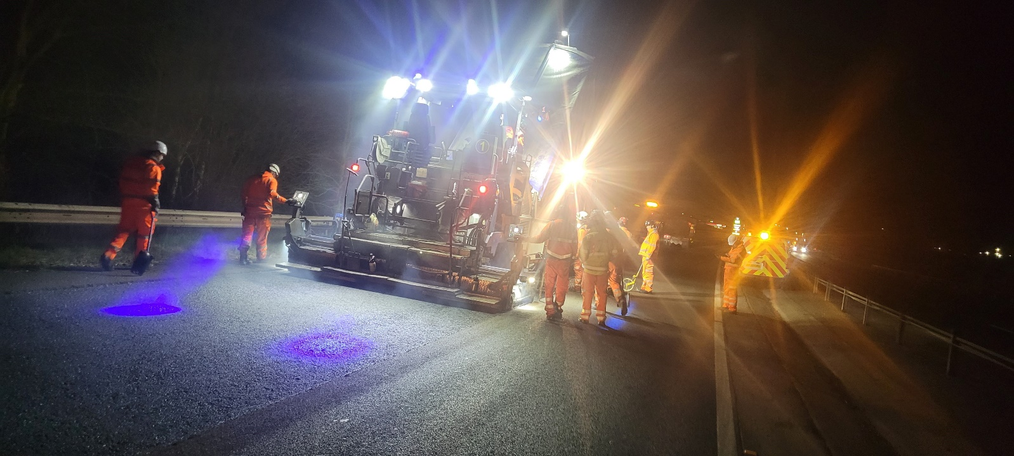
Background
Following a mini bid competition exercise, ERH Ltd. were awarded this extensive contract scheme which entailed the resurfacing and strengthening of approximately 9.5km of both the east and westbound carriageways between the A40 Raglan Interchange and the Monmouth Tunnels.

To allow the works to take place, it was necessary to implement a diversionary route of approximately 106 miles, allowing a full road closure along the stretch of the A40 Monmouth to Raglan carriageway. This allowed the work to be carried out safely and effectively.

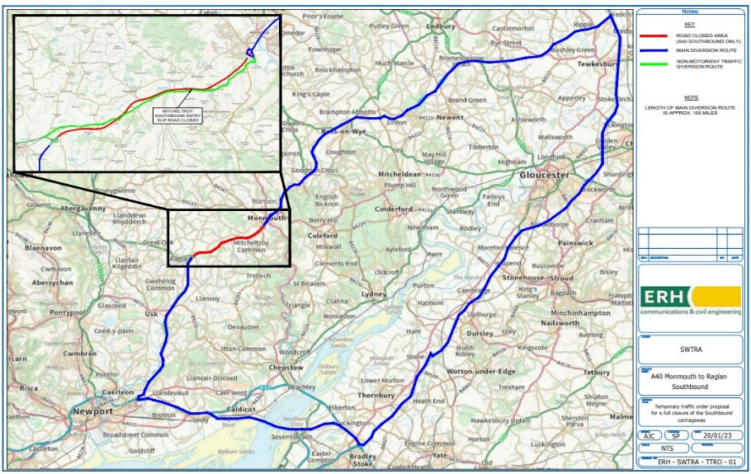

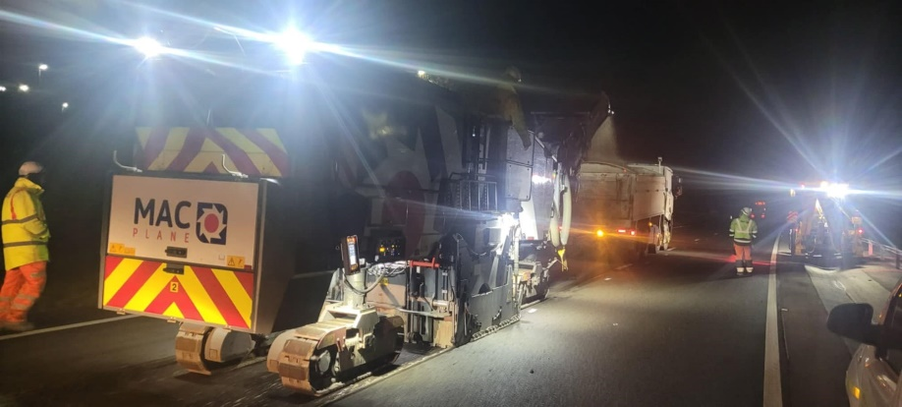
Several separate scheduled maintenance works were also coordinated with various contractors along the M4, M5 and M50 that clashed with the respective works. To mitigate this, we maintained daily correspondence and attended regular meetings with several network planners, working with them
to ensure that our diversionary route was kept unobstructed.

Challenges
Multitudinous national events were planned in the Cardiff area throughout the duration of the works.
This greatly affected the flows of traffic into the area. The A40 Raglan to Monmouth is an integral route into and out of Wales decanting traffic to the northern area of the UK and so extensive coordination, communication and collaboration was paramount to ensure the successful delivery of the Scheme. Close liaison was maintained throughout between three separate area departments of National Highways (bordering the M5), Emergency Services, Monmouth and Newport councils, Bristol Airport and the Prince Charles and Severn Bridge Crossings Management Teams.

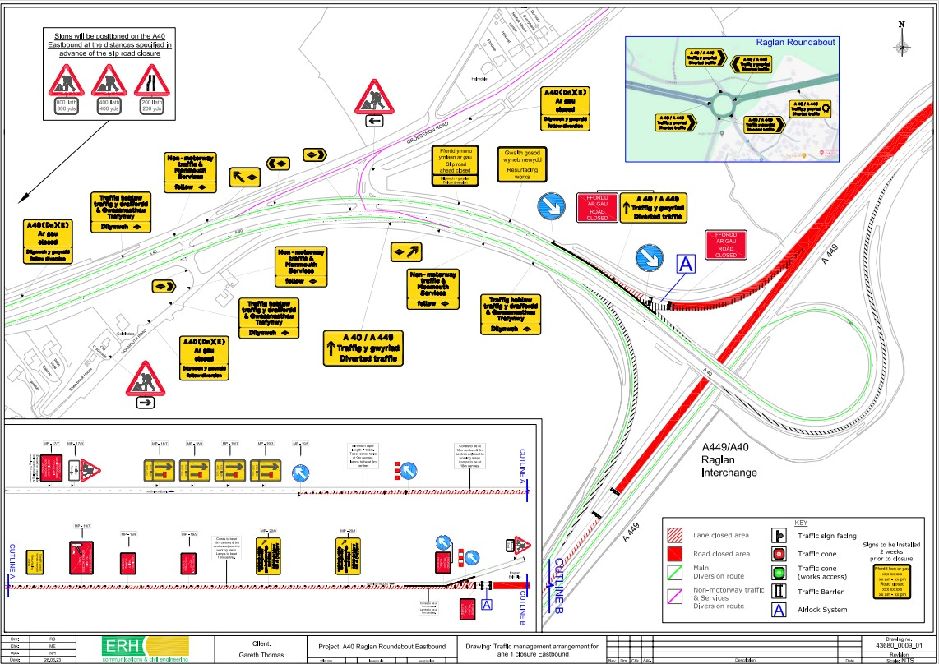
Traffic Management
ERH Ltd, oversaw and managed the fulfilment of all Traffic Management elements and responsibilities of this contract. ERH Ltd. are the sister company of Centregreat Ltd. They are a Sector Scheme (12A, B, & D) approved company with highly experienced, qualified, and competent TSCOs and staff possessing the ability to produce AutoCAD Traffic Management Drawings plans compliant with the Chapter 8 of the Traffic Signs Manual. This affords greater flexibility for our clients should we need to make last minute adjustments to drawings or arrangements on site, we can do so at short notice.

Traffic Management Added Value
In addition to our vast knowledge and experience of effective traffic management arrangements, our in-house delivery model provides value through the following benefits:
Bespoke TM Sign Making: Bespoke TM signs were manufactured through our in-house signage making facility, that produces a range of standard and bespoke signs, including Chapter 8 compliance, at short notice. This facility has proven invaluably useful, especially in the production of emergency signage.
TM Accredited Management Systems: ISO 9001, 45001 and National Highways Sector Scheme (NHSS) 12A, 12Band 12D Accredited Management System - Forms the basis for all our works activities and assists in the effective management of risk, reducing costs to our clients through efficiency savings.
Members of the Traffic Management Contractors’ Association: By ERH Ltd. being members of the TMCA, we are constantly up-to-date with the latest changes in regulations in traffic management and updating our knowledge consistently.

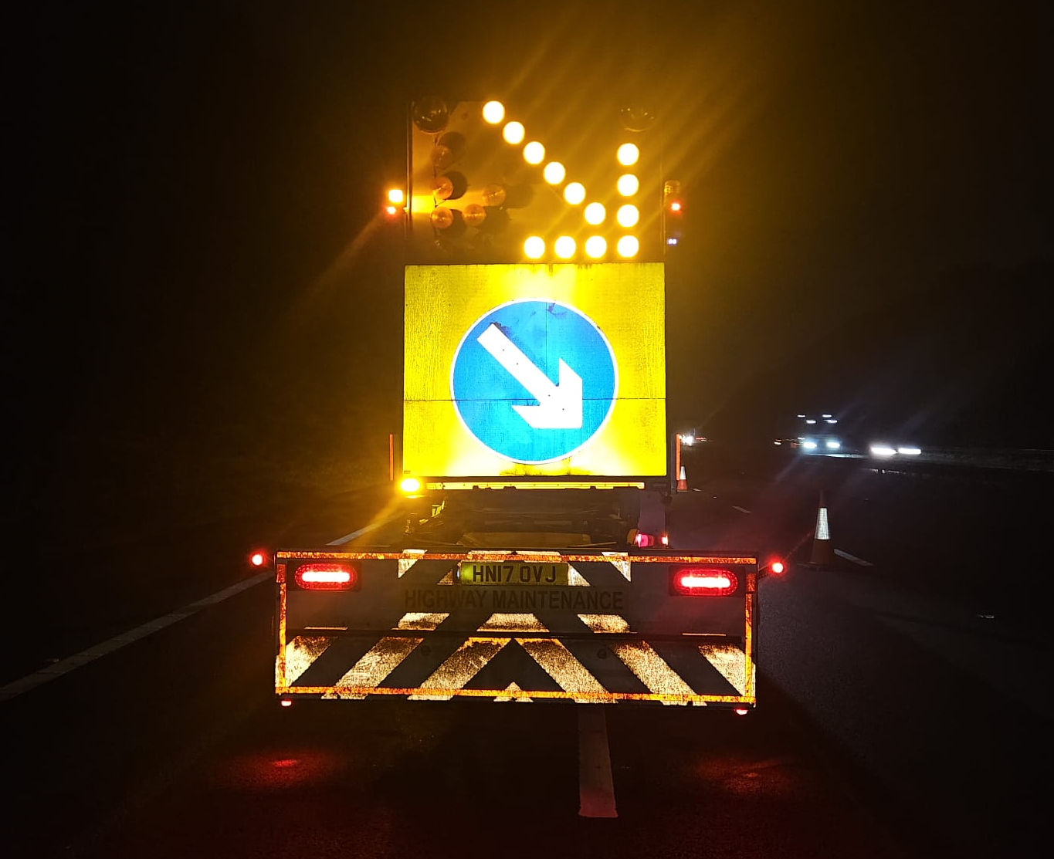

Client: Welsh Government/SWTRA Value: XXXXXX Contract: Surfacing and Ancillary Works FW Delivery Period: XXXXXX

