M4 Westbound Resurfacing J26 Malpas to J28
Tredegar Park
Case Study

Background
The works comprised of resurfacing the westbound M4 carriageway between J26 to J28. ERH Ltd. worked in conjunction with Centregreat Ltd. and their strategic delivery surfacing subcontract partner, Breedon Group. ERH Ltd. implemented a full closure of the M4 westbound between junctions 25a and 28 to deliver the carriageway resurfacing works on behalf of SWTRA.

Challenges
The carriageway closure implemented by ERH Ltd., was considered high-profile due to the heavy traffic volumes and busy congestion periods experienced on this stretch. The M4 J26/28,situated just after the Brynglas Tunnels serves as a gateway to Wales and is a key route for tourists entering South Wales and for holidaymakers travelling to Cardiff Airport. Over a typical 24hr period, 114,000 of all types of vehicles were travelling westbound). The works had to be undertaken and fulfilled within a strict working time remit between 8pm to 6am with very limited scope for over running due to the location and heavy commuter traffic flows heading into and out of Wales.

Traffic Management
ERH Ltd, oversaw and managed the fulfilment of all Traffic Management elements and responsibilities of this contract. ERH Ltd. are the sister company of Centregreat Ltd. They are a Sector Scheme (12A, B, & D) approved company with highly experienced, qualified, and competent TSCOs and staff possessing the ability to produce complex AutoCAD Traffic Management Drawings plans compliant with the Chapter 8 of the Traffic Signs Manual. This affords greater flexibility for our clients should we need to make last minute adjustments to drawings or arrangements on site, we can do so at short notice.

Prior to the works commencing, rigorous planning with Newport Council, SWTRA and other third-party stakeholders was undertaken to obtain road space permits and permission to use the lengthy diversion route on their highway network. This involved several meetings with all parties present to effectively coordinate the TM arrangements – factoring in all local usages of the affected diversions routes and checking that no works were scheduled along the road and that no planned events would further affect traffic flows and congestion.

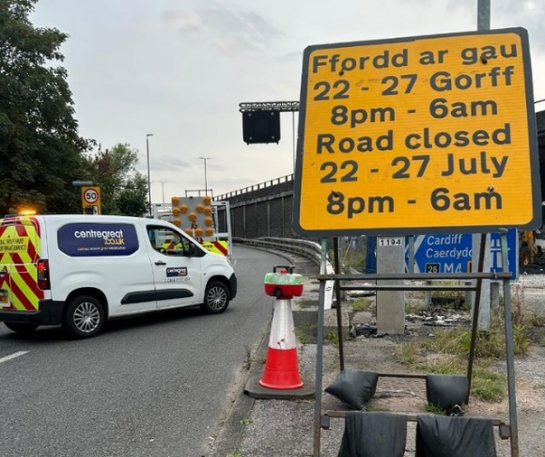

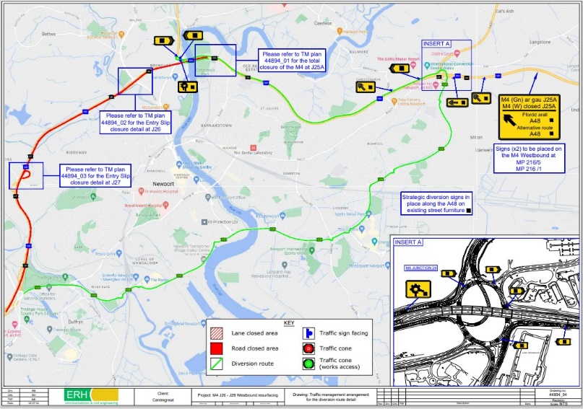
Added Value
In addition to our vast knowledge and experience of effective traffic management arrangements, our in-house delivery model provides value through the following benefits:
Bespoke TM Sign Making: Bespoke TM signs were manufactured through our in-house signage making facility, that produces a range of standard and bespoke signs, including Chapter 8 compliance, at short notice. This facility has proven invaluably useful, especially in the production of emergency signage.

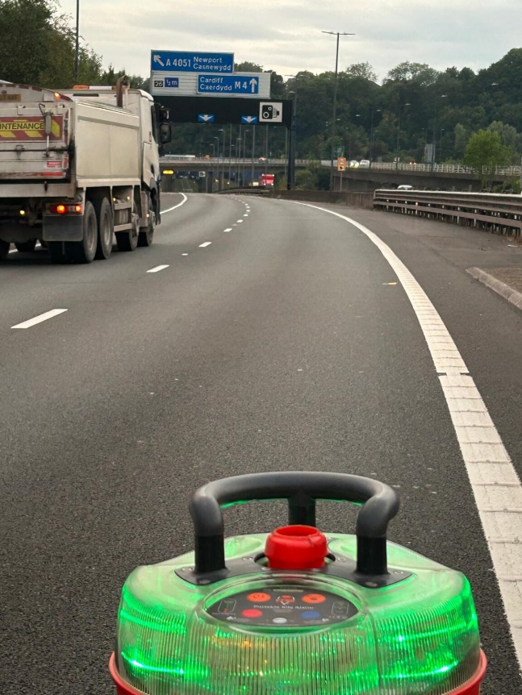
The Echelon paving operations were spread throughout the site, reducing the space available for passing vehicles, thereby increasing the risk of errant vehicles coming too close. When activated, the Incursion Prevention & Warning System triggers an instant visual red flashing light and an audible sound at 96 decibels from each Portable Site Alarm.
This alerts everyone onsite to a potential security breach. Once the threat has passed and site integrity is confirmed, Ricky can authorize a system reset. This action causes all Portable Site Alarms to revert to green, indicating that the site is safe to continue work. The crews from Breedon were comfortable using the equipment, as they had already encountered it during their work on the National Highways Network. The contractors expressed feeling safer knowing that the HRS system was in place for this contract.

Traffic Management Innovation - Incursion Prevention & Warning System (IIPAWS)
In view of the growing concern for incursions involving vehicles entering the road closure work zone areas, particularly at night poses a considerably risks to the health, welfare and safety of our operatives - We are the first Traffic Management provider to fully utilise and implement the Incursion Prevention & Warning System (IIPAWS).
With the M4 J26 - 28 M4 road closure, the lengthy diversion pushed traffic in the opposite direction from the closure points at the junction 26 and 27 entry slips. This raised concerns about incursions. As a result, ERH called upon HRS to enhance safety by implementing the Incursion Prevention & Warning System. The system provided operatives with red “Portable Site Alarms” at each closure point. Each alarm is connected via a Multi-Network SIM, ensuring continuous connectivity even in poorly connected areas. Contractors were also equipped with blue “Portable Site Alarms,” which they always kept with them.
The Site agent, Ricky Thomas, working on behalf of ERH, conducted a site test on the first night of the closure. Ricky pressed the red alarm button at the mainline closure point, and a supervisor from Breedon immediately called him to ensure everything was alright. This test proved the alarm system’s effectiveness in a busy resurfacing operation, where the two pavers were undertaking the Echelon Paving with approximately 40 contractors onsite each night.

TM Accredited Management Systems: ISO 9001, 45001 and National Highways Sector Scheme (NHSS) 12A, 12Band 12D Accredited Management System - Forms the basis for all our works activities and assists in the effective management of risk, reducing costs to our clients through efficiency savings.
Members of the Traffic Management Contractors’ Association: By ERH Ltd. being members of the TMCA, we are constantly up-to-date with the latest changes in regulations in traffic management and updating our knowledge consistently.

Client: Welsh Government/SWTRA Value: Approximately £10m Per annum Contract: Surfacing and Ancillary Works FW Delivery Period: 25th - 27th July 2024

