A4119 Talbot Green
Traffic Signal Improvements Phase 2
Case Study

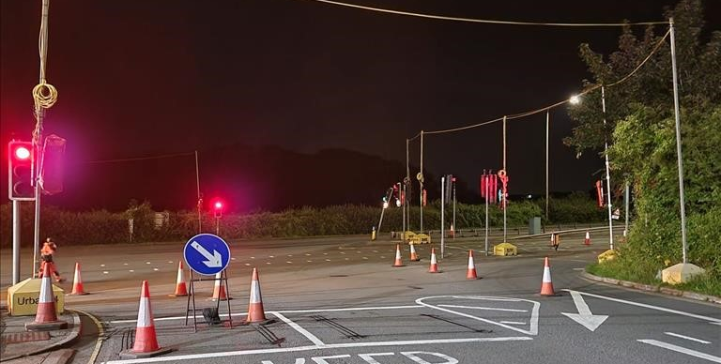

Background
The required Signal Scheme Improvement works were located at a busy junction of the A4119 Ely Valley Road which acts as the main commuter road feeding into Junction 34 of the M4. It also conjoins with the B4595 Talbot Road that serves the community belt of residential housing located adjacent to the M4 corridor.

The junction is extensively used by public transport and is situated in close proximity to a thriving hub of local amenities and businesses including a busy petrol station, a DVSA driving test centre (for both light and heavy goods vehicles), an active 24 hour operational VOSA testing centre facilitating the inspection of commercial vehicles surveyed and brought to the premises by the police and VOSA themselves after performing random roadside checks along the M4.

Additionally, we also had to take into account that this particular stretch of the A4119 accommodates the frequent transit of heavy vehicles carrying abnormally large and heavyweight payloads, such as fabricated bridge structures and wind farm turbines. To facilitate the safe passage of these irregularly large freights along the route, Police escorts were required.

Delivery
Centregreat were awarded the framework scheme contract by Rhondda Cynon Taff County Borough Council to:

- Plane off and lay new road surface
- Lay road markings
- Install traffic signal looping, ducting, cabling and upgrade of the signal controller and replacement of signal with built in speed camera with the requirement for the camera to remain live and operational throughout the improvement scheme.

Outcome: The works were successfully delivered on programme, within budget and to a high standard.

To accommodate these convoys during the signal replacement works we ensured that clear and open communication channels were established and maintained with each of the respective transportation and logistics companies, highways network and transport police to effectively coordinate, plan and enable us to adjust our traffic management arrangements, accordingly, allaying any disruptive impact.

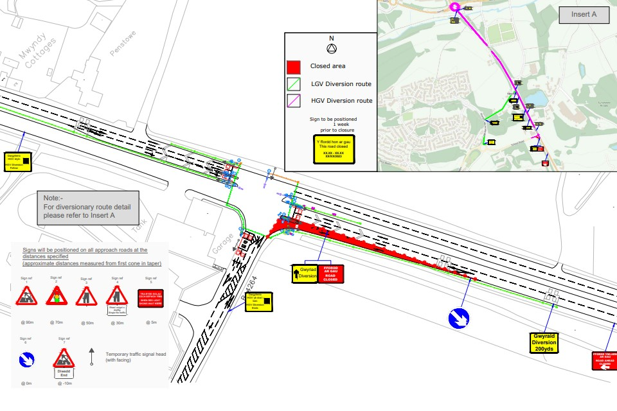
ERH Ltd - Traffic Management
To facilitate the required works being carried out, ERH Ltd, successfully undertook all of the Traffic Management elements and responsibilities of the contract. ERH Ltd. are the sister company of Centregreat Ltd. They are a Sector Scheme (12A, B, & D) approved company with highly experienced, qualified, and competent TSCOs with 3 main personnel in our management team having over 60 years of insight and experience within the Traffic Management industry. Additionally, staff possess the ability to produce complex AutoCAD Traffic Management Drawings plans compliant with the Chapter 8 of the Traffic Signs Manual. This affords greater flexibility for our clients should we need to make last minute adjustments to drawings or arrangements on site, we can do so at short notice.

The use of our in-house Traffic Management for both design and execution of the traffic management function provides Centregreat greater commercial and operational flexibility from the use of external sub-contractors. This enables us to work collaboratively with the client to assist in both meeting their spend profile and delivering significant efficiency savings for the contract.

Sufficient time allowances within our programme were factored to ensure that all appropriate TTRO were booked in advance, some 3 months ahead of the of scheme works commencing including the timely provision of Road Space Applications, traffic safety and management proposals and processes submitted by our TSCO. A road full road closure with an appropriate diversionary route was required to facilitate the laying of the road crossing markings at the junction as without the closure there was insufficient remaining residual road width to situate Traffic Management to ensure safe working areas.

Innovations - Temporary Traffic Management Intelligent System - Urban 64
ERH utilised their relationship with SRL to deploy SRLs mirroring temporary traffic management system, Urban 64. This intelligent system was first used by Centregreat on a recent Signal installation scheme contract delivered at the Park St/Angel St intersection in Bridgend under the SEWH Framework, which was a resounding success. Testament to the smooth and disruption free delivery of the scheme, the Local Authority (The Bridgend County Borough Council) sought and acquired further funding in order for the Urban 64 system to be implemented again for a successive traffic signal replacement scheme undertaken by ERH at Coity Interchange.

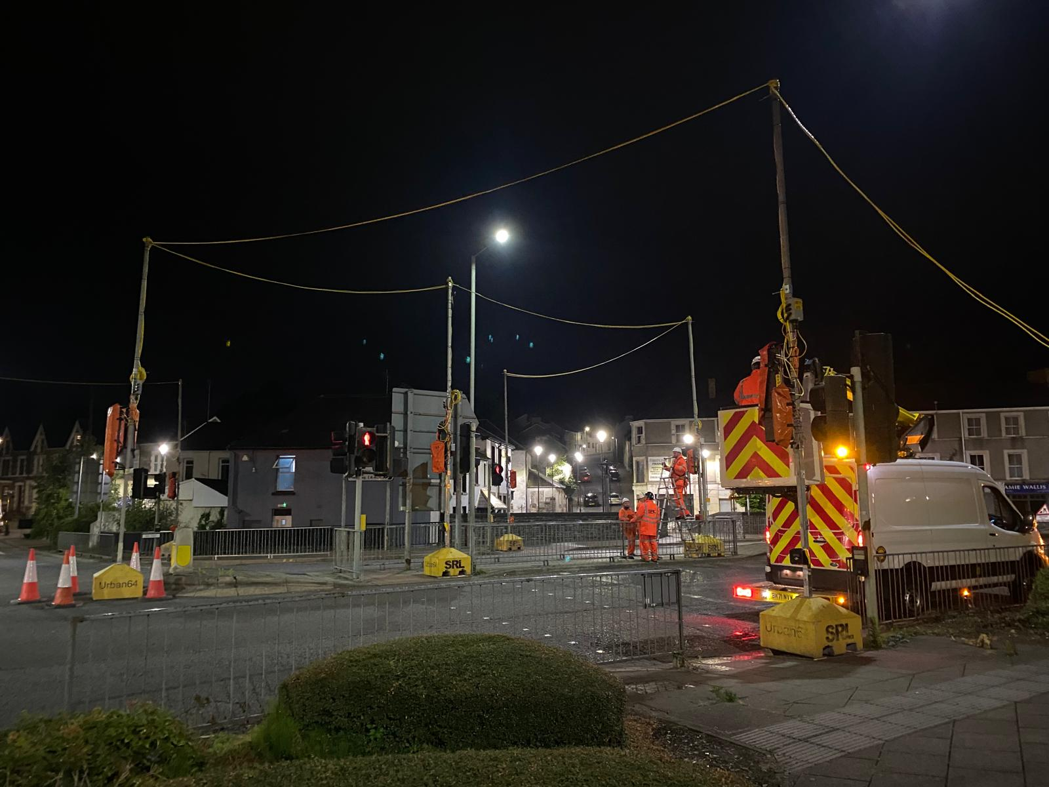
Implementing Urban 64: The temporary traffic signals were provided by SRL implementing their Urban 64 intelligent system and its benefits throughout the scheme works being undertaken, enabling flawless implementation of separately signaled movements that would greatly improve junction efficiency, deliver cost certainty, and promote traffic efficiency and safety.

ERH worked in conjunction with SRL to firstly produce a comprehensive Urban 64 layout design to maximize the efficient operation of the junction whilst enabling the signal refurbishment works and access around the site location. A site visit was initially carried out to agree and mark-out the block positions followed by the installation of the system being undertaken in one night using a three-way lane closure, with minimal disruption to traffic. Appropriate Traffic Management was implemented by ERH with the use of a Dedicated Impact Protection Vehicle (DIPV) and high-speed lane closures along with the use of standard temporary traffic signals lights in lieu of the permanent junction signals which had been disconnected. The Urban 64 Traffic Management Intelligent System was delivered and installed by SRL using an Artic Lorry.

Urban 64 Advantages: This Temporary Traffic Signal System uses above ground and overhead cabling that accommodates the height of high vehicles and factors Road bridge Regulation Heights, enabling the SRL team to safely situate and assemble the Urban 64 system, like-for-like, with precision into the same position as the existing original signals - effectively replicating/mirroring the preceding system with ease and expedience.

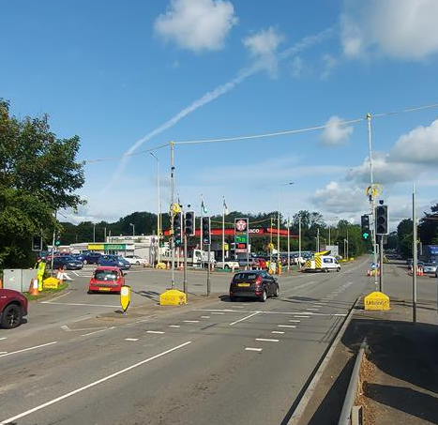
Testimonials
“Given the pressure the local authority was under to minimise disruption to traffic at this this very strategic junction, we were very pleased with how quickly the scheme progressed to completion within the agreed programme. The contractor was very flexible to the demands of the contract”.
Andrew W Phipps, Street Lighting and Traffic Signal Manager,Rhondda Cynon Taff County Borough Council

A further advantage of Urban 64 is that its power access connects to the same permanent energy supply source that the preceding signals use, eliminating any disruption of power unlike standard temporary lights which would cause disruption and congestion. Once the intelligent system was placed in and was operational, we removed our standard temporary signals and withdrew the lane closures.

By replicating the permanent system, Urban 64 delivers several benefits vs its portable alternative. When adopting the use of conventional portable signals it isn’t possible for individual pedestrian phases to run with specific traffic movements (walk with traffic). Under a portable arrangement, vehicular traffic needs to stop on all approaches to allow pedestrians to cross on each arm. Another downside of using a portable system on a scheme of this size, is that pedestrians would need to cross the road in two cycles – one cycle to cross into the central islands, and another cycle from the centre islands to the other side of the road.

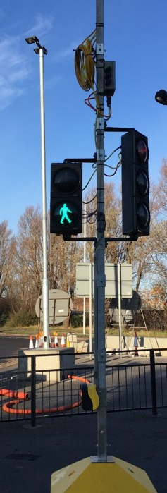
Urban 64 provides a dynamic solution which utilizes VA (Vehicle Actuation) to extend green times as required and so was able to accommodate these needs with adjustable filter/ indicative phases and ‘walk with traffic’ pedestrian facilities. The system also uses Microprocessor Optimized Vehicle Actuation (MOVA) signal control strategies to improve system efficiency. The efficacy of the MOVA control was particularly demonstrated when the A4119 route experienced an increase in the traffic flow frequency of HGVs and tractors carrying abnormal payloads who passed within the perimeter area of the temporary lights. The system’s logger rhythms detected the heavy vehicles and adjusted and extended the green times automatically and accordingly to factor the slower movement of heavy vehicles in transit.

Additionally, the system has an inbuilt camera surveillance capability that can capture events (E.g. such as a jumped traffic signal followed by a subsequent incursion of vehicles caused by a unfortunate bump), with SRL storing the footage for evidential purpose for our viewing as well as the police and highway authorities. The timings on the traffic flows can also be altered remotely should the need arise. The system is health checked on a regular basis and has a default to call/message/email ass SRL Urban 64 engineers should any issues occur. Essentially, the Urban 64 system is more effective than the standard permanent signals that they replicate. Throughout the entire hire period for the scheme, smooth and steady three-way traffic flows were always successfully maintained at this busy junction for the duration of the Works. The RCTCBC reported zero faults, and perfect reliability.

Cost Savings
A further signal improvement task order had been placed by the RCTCBC that also required the corresponding use of Urban 64 to facilitate the refurbishment. This work was scheduled to commence at the intersection on the opposite side of the A4119, adjacent to the Castell Mynach Pub.

As this new site location was in such close proximity to the newly completed works at School Road junction, it provided the expedient means for our team to re-deploy our Traffic management and equipment set up bespoke to the new site, essentially negating the requirement for us to off-hire the Urban 64 system and subsequently saving us any re-hire cost from SRL. This ultimately enabled us to provide the Client with a significantly discounted price for the Urban 64.

Utilising our In-house - turnkey approach helped to reduce overall costs and provided greater control and coordination of the varying elements of works required for the refurbishment scheme. Our Centregreat Traffic Signal Division, Signage Divisions were fully deployed, along with our aforementioned Centregreat Company ERH Traffic Management. This also had the added benefit of a familiar operational team working on site aiding both coordination and production.

Client: RCTCBC
Contact: Andrew Phipps
Email: andrew.w.phipps@rctcbc.gov.uk Value: £184K Contract: SEWH Framework Delivery Period: January – March 2023

